1] The GUI

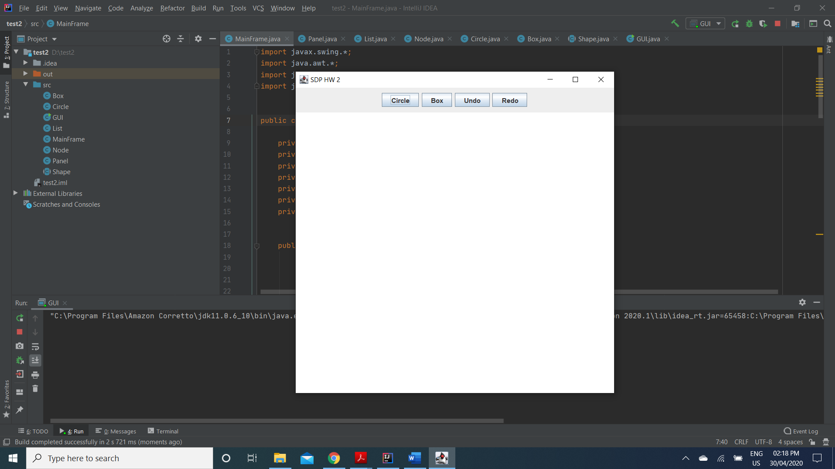

2] On selecting Circle and clicking on the ContentPanel:

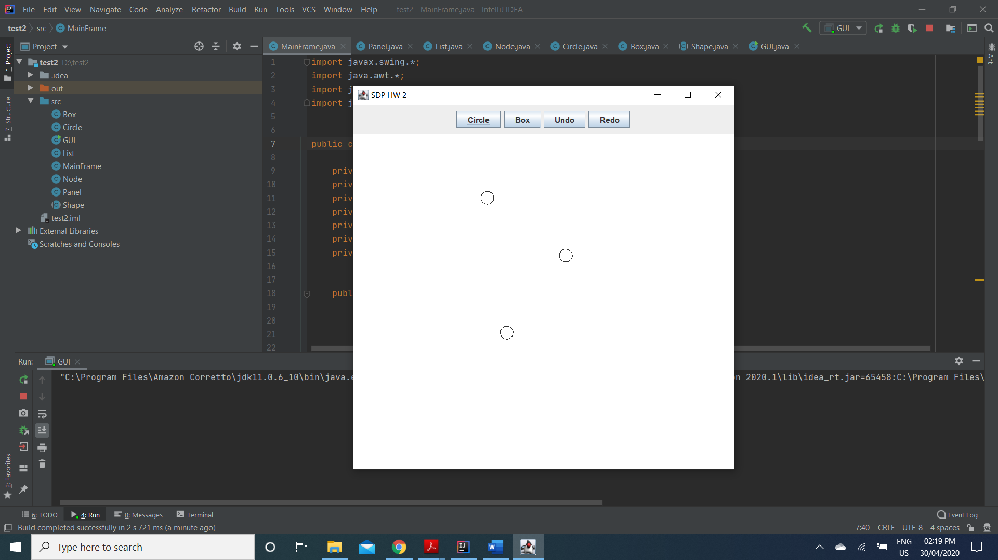

3] On selecting Box and clicking on the ContentPanel:

A] 1st box:

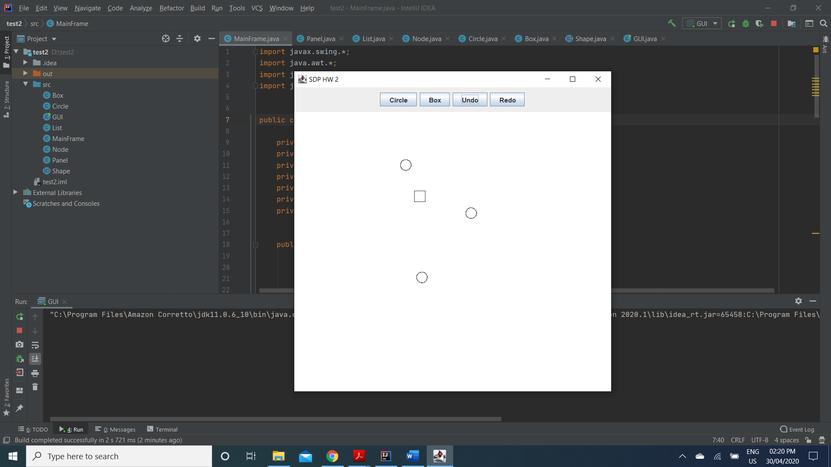

B] Overlapping with circle:

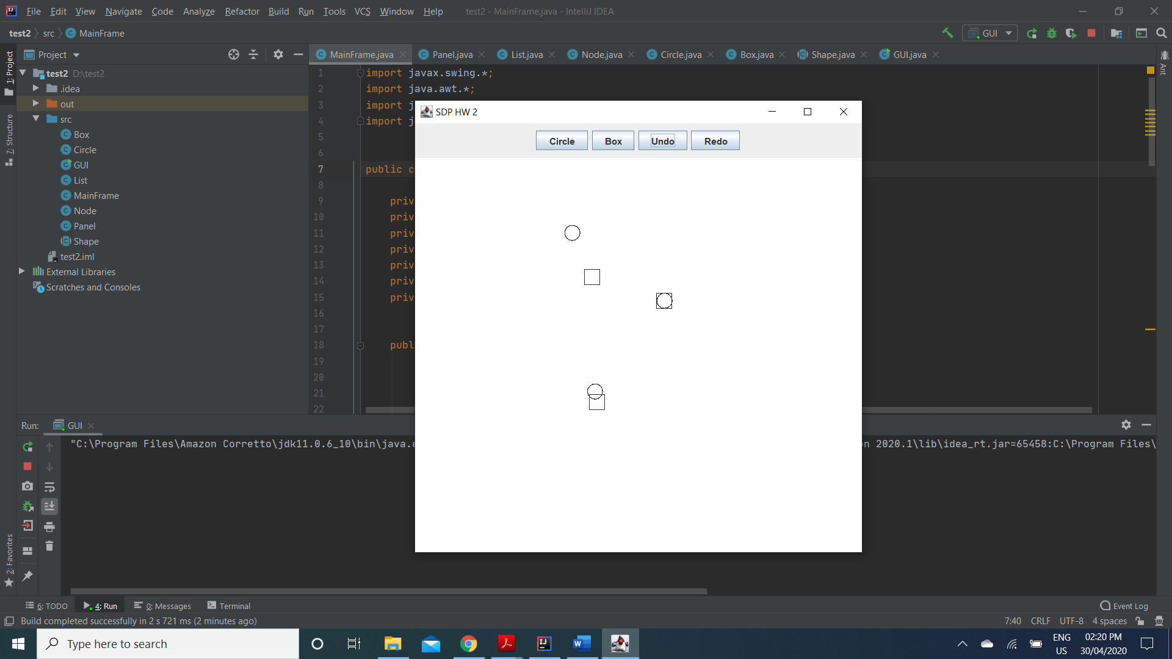

4] On selecting the Undo button:

A] The 3rd Box disappears:

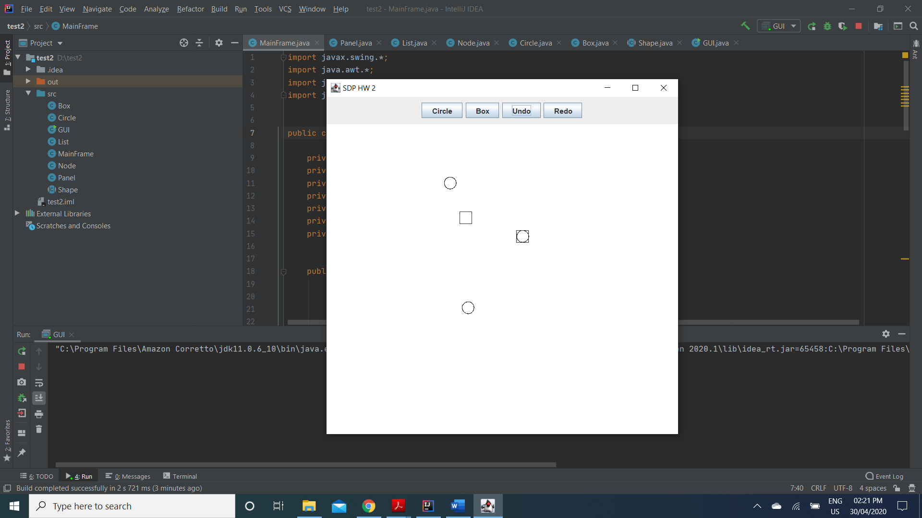

B] The 2nd Box disappears:

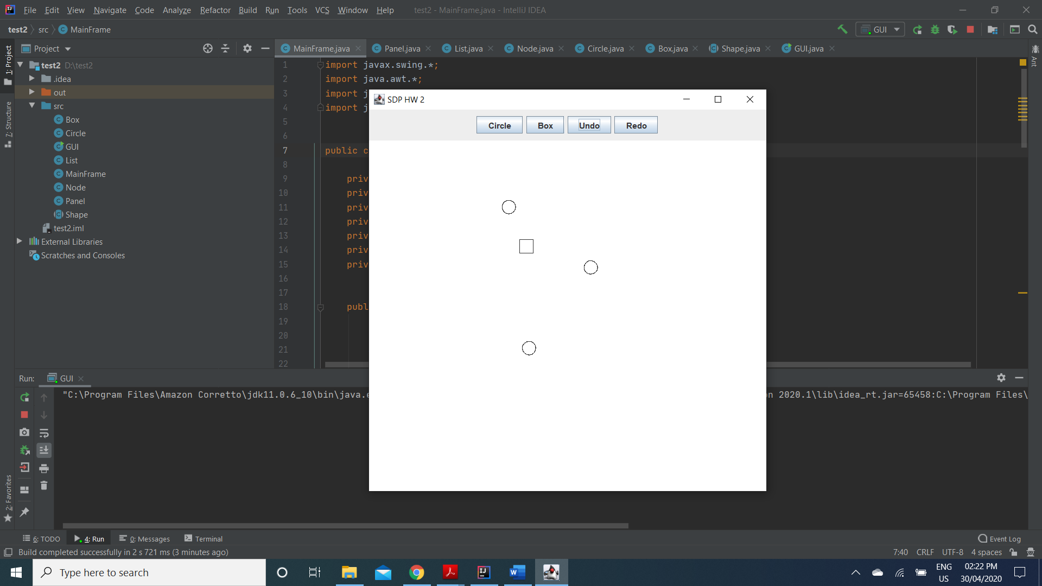

5] On selecting the Redo button:

A] The second Box reappears:

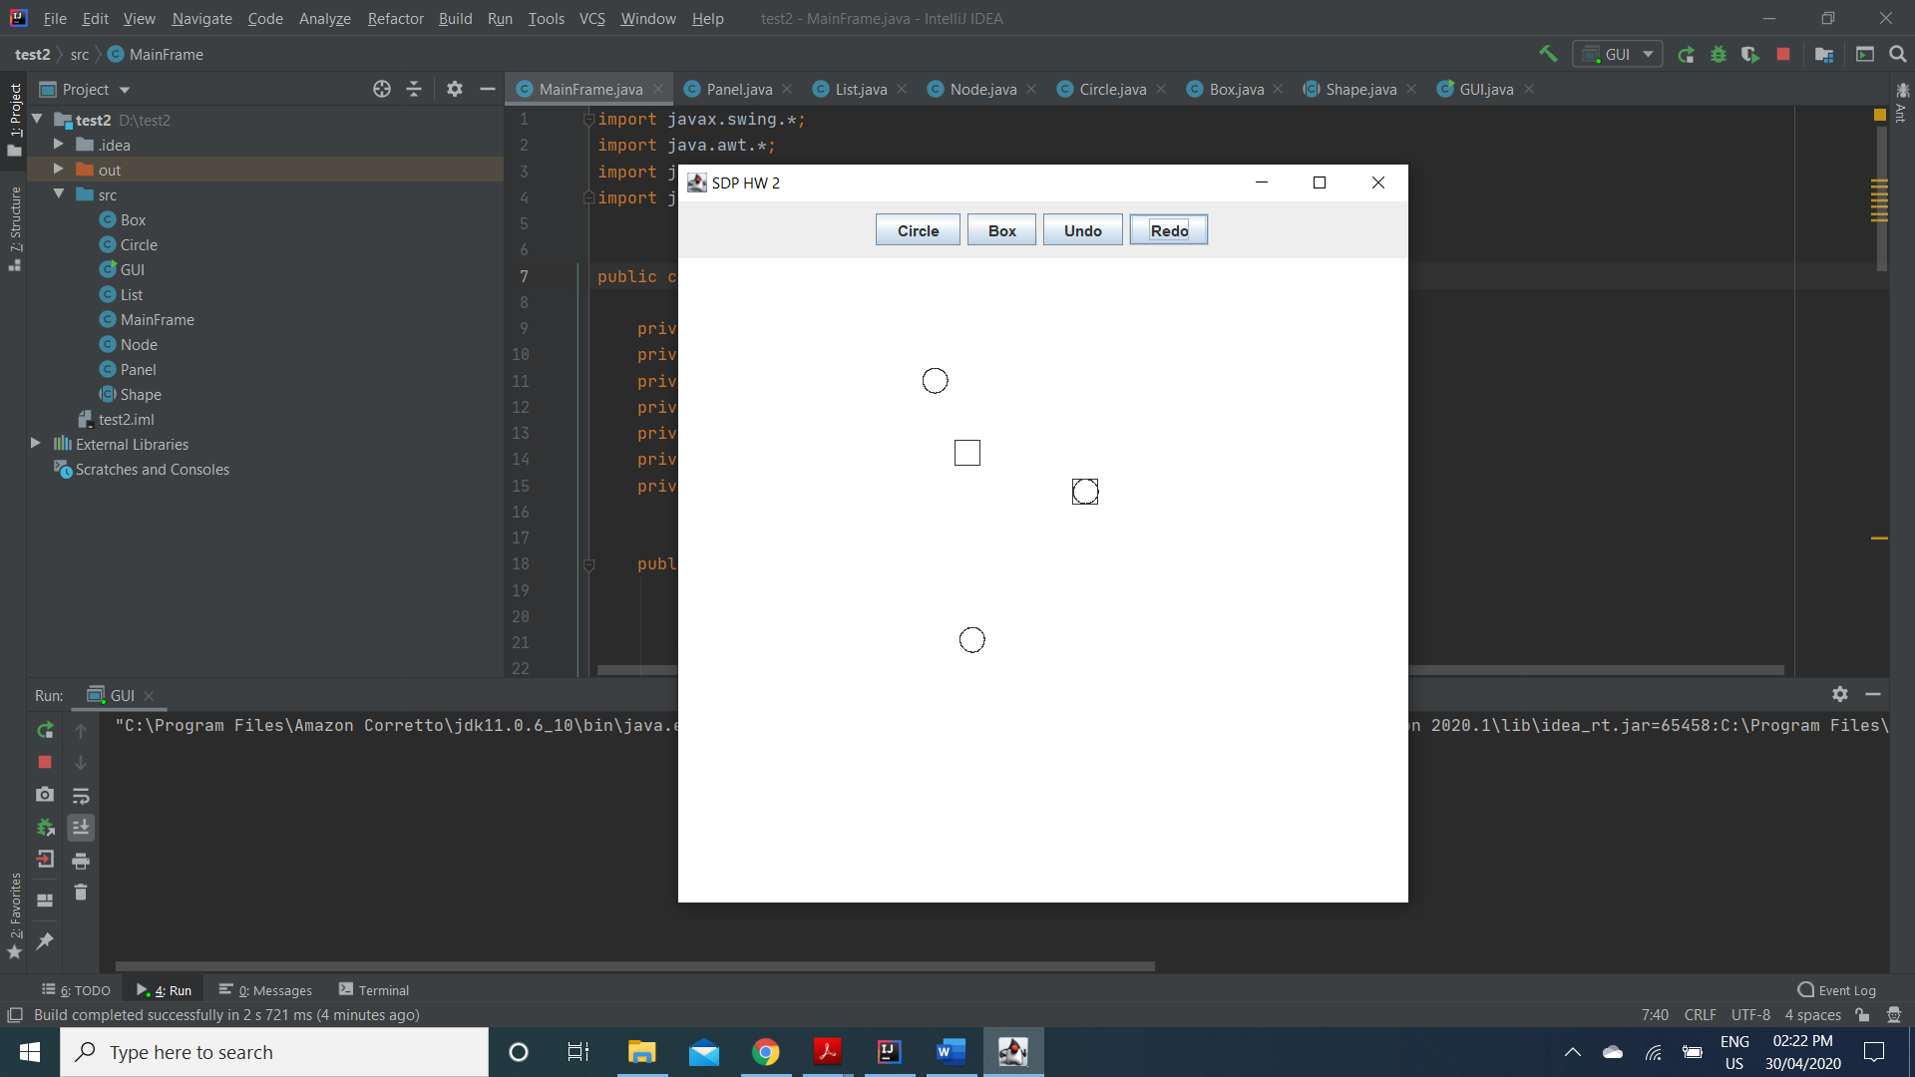

B] The 3rd Box appears:

